Test Results

a. I have used the Moons dataset generated using the scikit-learn datasets.

1. Random Seed used: 100

Incorrectly predicted Labels: 0

f functions histogram:

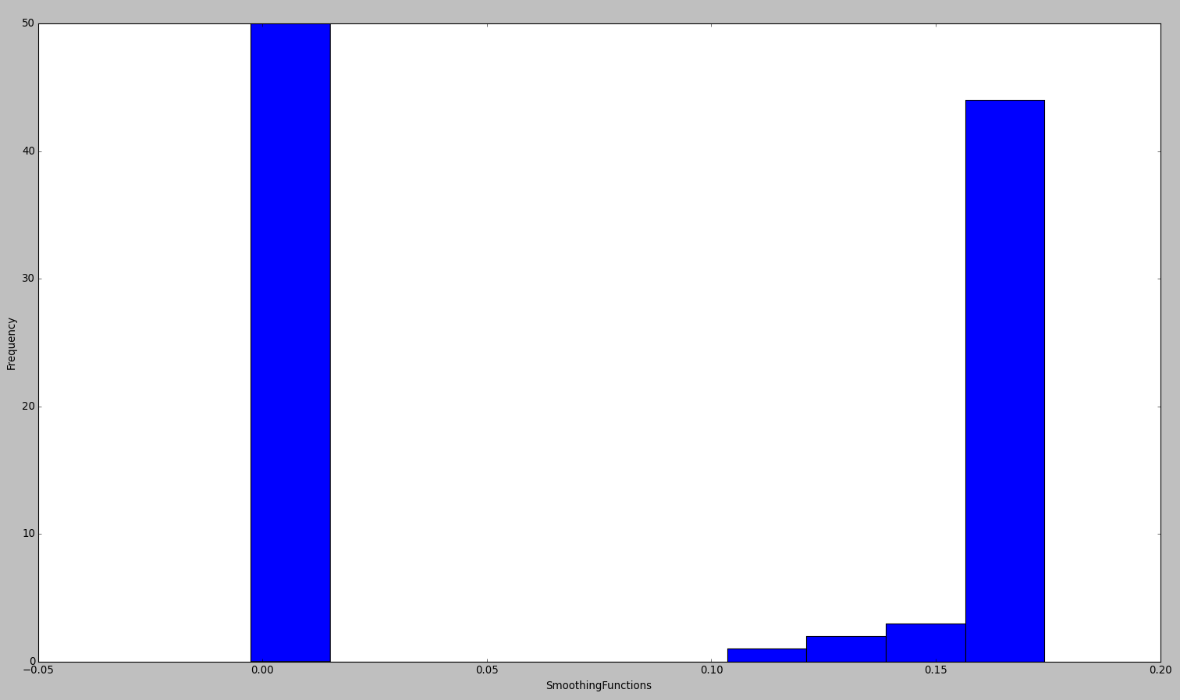

Learned GMM Parameter:

GMM learned parameters:

GMM(covariance_type='diag', init_params='wmc', min_covar=0.001,

n_components=2, n_init=1, n_iter=100, params='wmc', random_state=None,

thresh=None, tol=0.001, verbose=0)

weights_

array([ 0.50004049, 0.49995951])

weights_

array([ 0.50004049, 0.49995951])

means_

array([[ 0.00409305],

[ 0.16450244]])

covars_

array([[ 0.00102464],

[ 0.00111567]])

converged_

True

2. Random Seed used: 999

Incorrectly predicted Labels: 1

The first data point of the lower half moon actually belongs to the upper half moon but is predicted wrongly as a data point of the lower half moon)

f functions histogram:

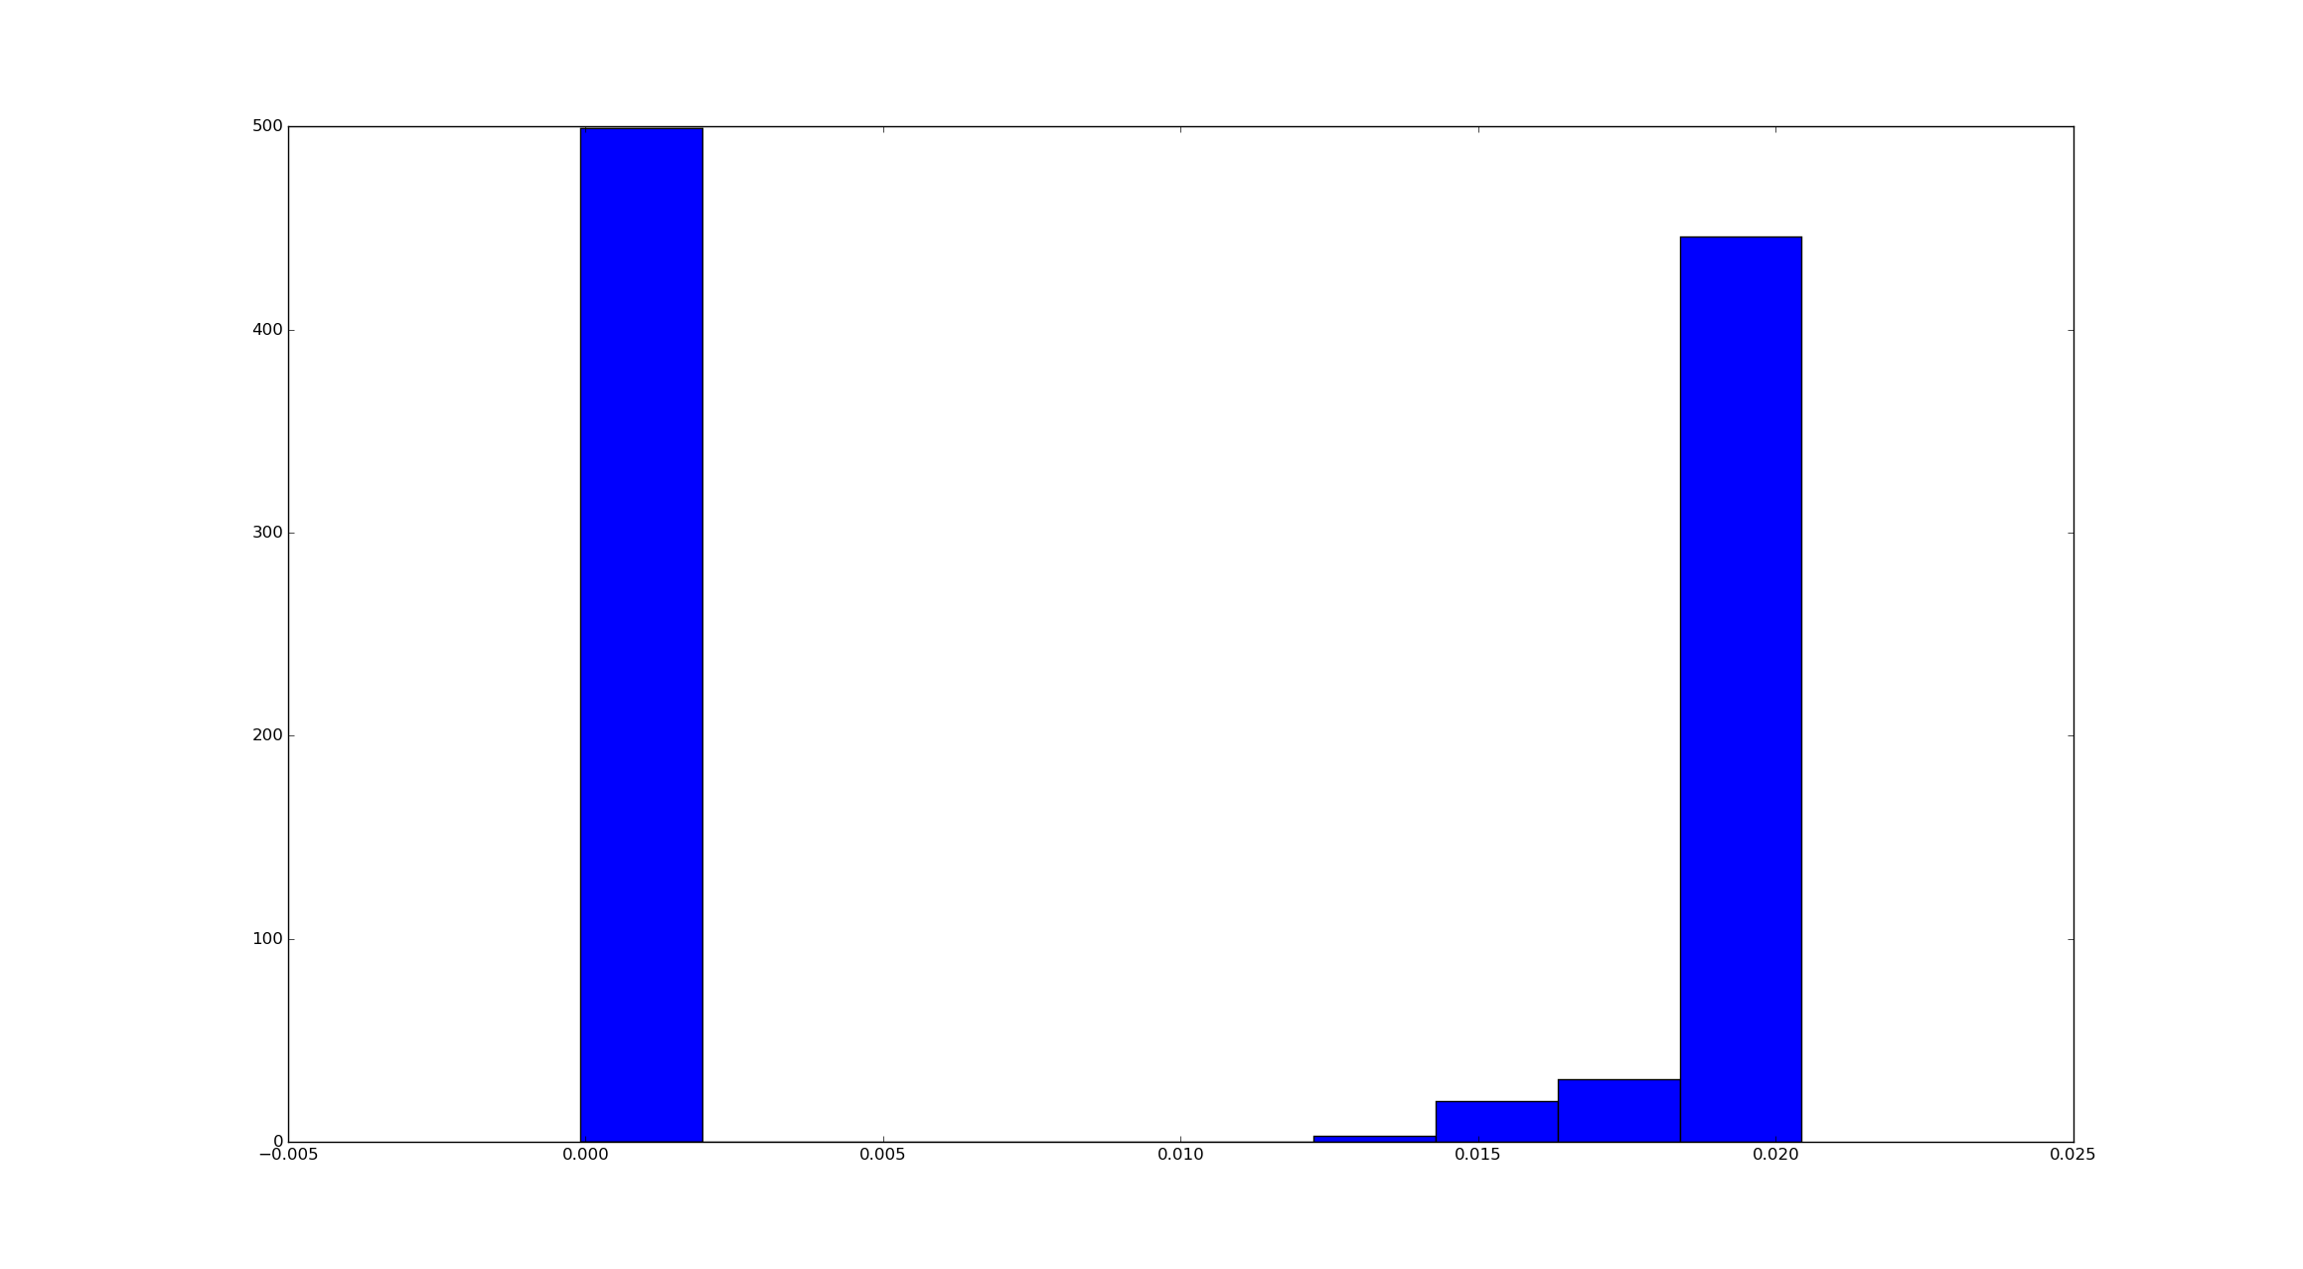GMM learned parameters:

GMM(covariance_type='diag', init_params='wmc', min_covar=0.001,

n_components=2, n_init=1, n_iter=100, params='wmc', random_state=None,

thresh=None, tol=0.001, verbose=0)

weights_

array([ 0.4999875, 0.5000125])

means_

array([[ 0.00992006],

[ 0.01005819]])

covars_

array([[ 0.0010928 ],

[ 0.00109282]])

converged_

True

3. Random Seed used: 5013

Incorrectly predicted Labels: 2507

Predicts the entire dataset with label '1'

f functions histogram:

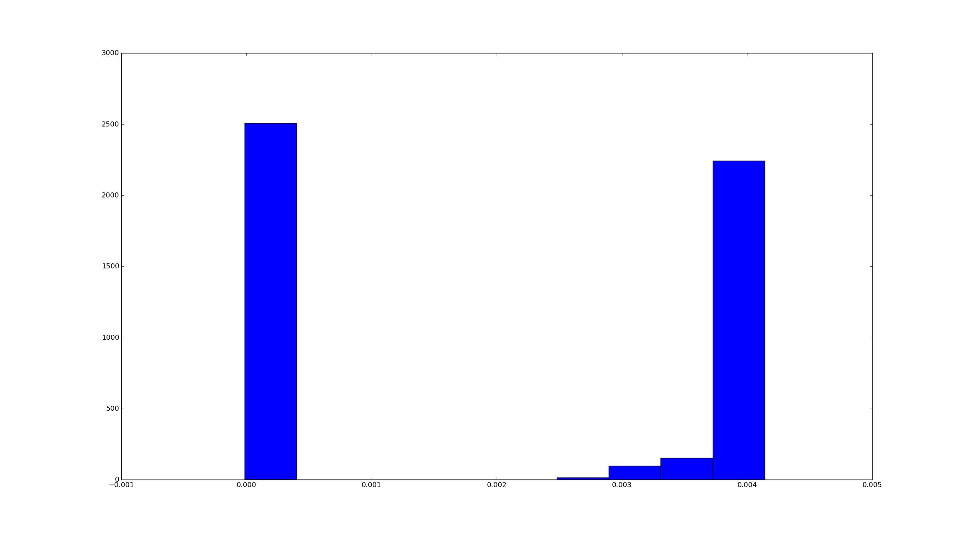

GMM learned Parameters:

GMM(covariance_type='diag', init_params='wmc', min_covar=0.001,

n_components=2, n_init=1, n_iter=100, params='wmc', random_state=None,

thresh=None, tol=0.001, verbose=0)

weights_

array([ 0.49999969, 0.50000031])

means_

array([[ 0.00202351],

[ 0.00202357]])

covars_

array([[ 0.00100382],

[ 0.00100382]])

converged_

True